**HADOOP CLUSTER MAINTAINANCE**

**Hadoop Admin** responsibility to perform Hadoop Cluster Maintenance frequently. Let’s see what we can do to keep our **Big Elephant Happy!**

**1. FILE SYSTEM CHECKS**

Develop a habit of Check health of HDFS periodically by running -fsck command

**hdfs fsck /**

This command contacts the Namenode and checks each file recursively which comes under the provided path. Below is the sample output of -fsck command.

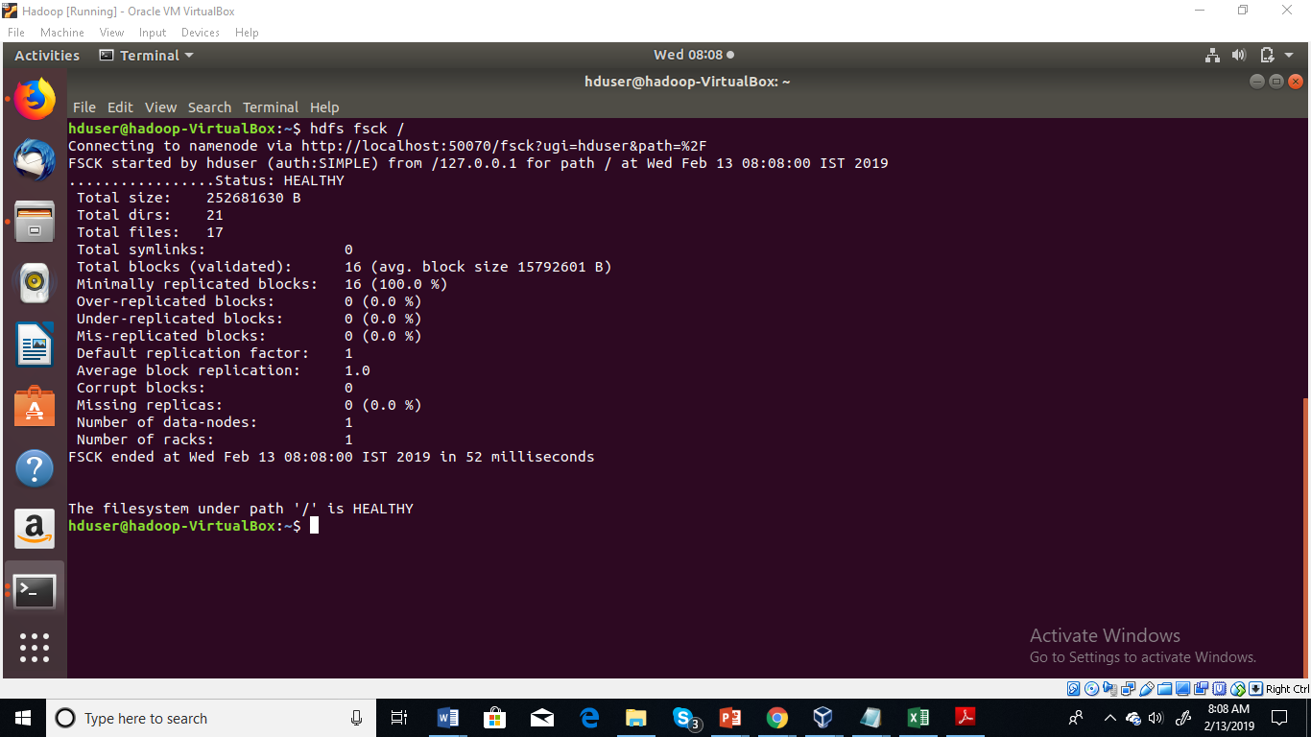

Other Usage:

Displays all the files in HDFS while checking

**hadoop fsck / -files**

Displays all the blocks of the files while checking

**hadoop fsck / -files –blocks**

Displays all the files block locations while checking

**hadoop fsck / -files -blocks –locations**

Command is used to display the networking topology for data-node locations

**hadoop fsck / -files -blocks -locations –racks**

**HDFS Balancer Utility**

Over the period of time data becomes un-balanced across all Data Nodes in the Hadoop Cluster, this could be because of maintenance activity on specific Data Nodes, power failure, hardware failures, kernel panic, unexpected reboots etc. In this case because of data locality, Datanodes which are having more data will get churned and ultimately ***un-balanced cluster can directly affect your MapReduce job performance.***

**hdfs balancer –threshold 1**

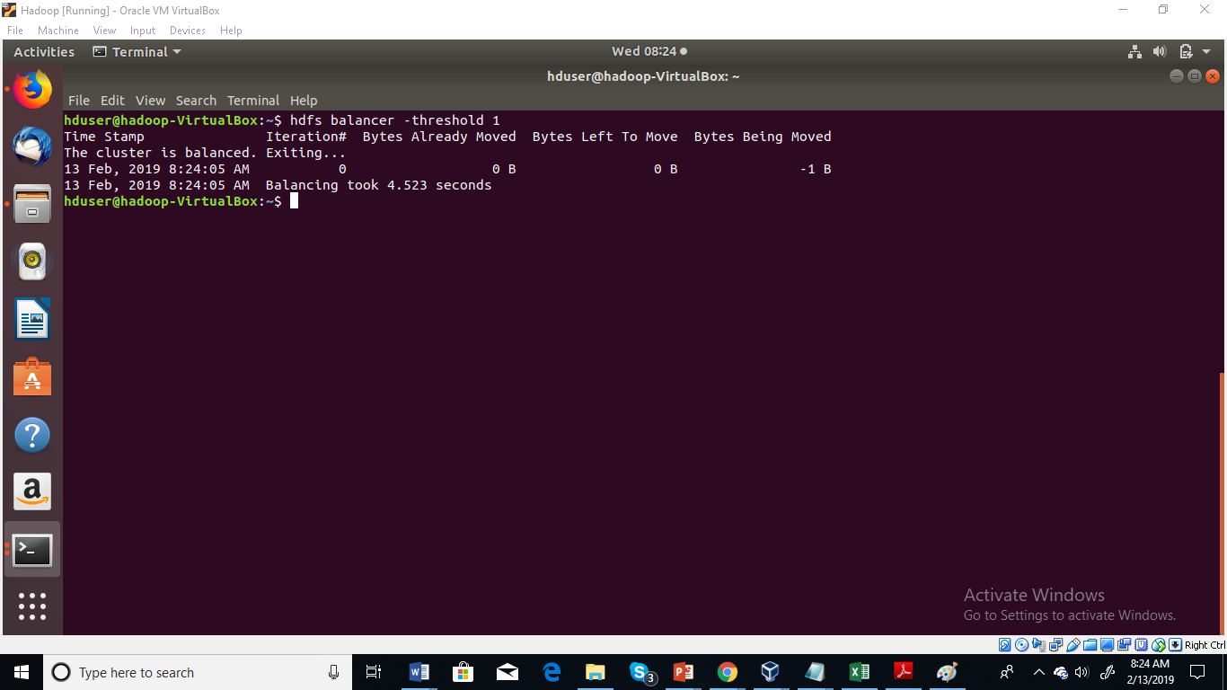

**By default threshold value is 10, we can reduce it upto 1 ( It’s better to run balancer with lowest threshold )**

Adjust the network bandwidth used by the balancer, by running the dfsadmin -setBalancerBandwidth command before you run the balancer

For example:

**dfsadmin -setBalancerBandwidth newbandwidth**

**PERFORMANCE TUNING**

**Let’s get into the game now:**

1. Resource Manager (RM) is responsible for allocating resources to mapreduce jobs.

2. For brand new Hadoop cluster (without any tuning) resource manager will get 8192MB (“yarn.nodemanager.resource.memory-mb”) memory per node only.

3. RM can allocate up to 8192 MB (“yarn.scheduler.maximum-allocation-mb”) to the Application Master container.

4. Default minimum allocation is 1024 MB (“yarn.scheduler.minimum-allocation-mb”).

5. The AM can only negotiate resources from Resource Manager that are in increments of (“yarn.scheduler.minimum-allocation-mb”) & it cannot exceed (“yarn.scheduler.maximum-allocation-mb”).

6. Application Master Rounds off (**“mapreduce.map.memory.mb”**) & (**“mapreduce.reduce.memory.mb”**) to a value devisable by (**“yarn.scheduler.minimum-allocation-mb”**).

**What are these properties ? What can we tune ?**

**yarn.scheduler.minimum-allocation-mb**

Sets the minimum size of container that YARN will allow for running mapreduce jobs.

Default value is 1024m

**yarn.scheduler.maximum-allocation-mb**

The largest size of container that YARN will allow us to run the Mapreduce jobs.

Default value is 8192m

**yarn.nodemanager.resource.memory-mb**

Default value is 8GB

Total amount of physical memory (RAM) for Containers on Data Node.

Set this property= Total RAM – (RAM for OS + Hadoop Daemons + Other services)

**yarn.nodemanager.vmem-pmem-ratio**

**Default value is 2.1**

The amount of virtual memory that each Container is allowed

This can be calculated with: containerMemoryRequest*vmem-pmem-ratio

**mapreduce.map.memory.mb**

**mapreduce.reduce.memory.mb**

These are the hard limits enforced by Hadoop on each mapper or reducer task. (Maximum memory that can be assigned to mapper or reducer’s container)

**Default value – 1GB**

**mapreduce.map.java.opts**

**mapreduce.reduce.java.opts**

The heapsize of the jvm –Xmx for the mapper or reducer task.

This value should always be lower than mapreduce.[map|reduce].memory.mb.

Recommended value is 80% of mapreduce.map.memory.mb/ mapreduce.reduce.memory.mb

**yarn.app.mapreduce.am.resource.mb**

The amount of memory for ApplicationMaster

**yarn.app.mapreduce.am.command-opts**

heapsize for application Master

**yarn.nodemanager.resource.cpu-vcores**

The number of cores that a node manager can allocate to containers is controlled by the **yarn.nodemanager.resource.cpu-vcores property.** It should be set to the total number of cores on the machine, minus a core for each daemon process running on the machine (datanode, node manager, and any other long-running processes).

**mapreduce.task.io.sort.mb**

**Default value – 100MB**

This is very important property to tune, when map task is in progress it writes output into a circular in-memory buffer. The size of this buffer is fixed and determined by **io.sort.mb property**

When this circular in-memory buffer gets filled **(mapreduce.map. sort.spill.percent: 80% by default)**, the SPILLING to disk will start (in parallel using a separate thread). Notice that if the splilling thread is too slow and the buffer is 100% full, then the map cannot be executed and thus it has to wait.

**io.file.buffer.size**

Hadoop uses buffer size of 4KB by default for its I/O operations, we can increase it to 128K in order to get good performance and this value can be increased by setting **io.file.buffer.size= 131072 (value in bytes) in core-site.xml**

**dfs.client.read.shortcircuit**

Short-circuit reads – When reading a file from HDFS, the client contacts the datanode and the data is sent to the client via a TCP connection. If the block being read is on the same node as the client, then it is more efficient for the client to bypass the network and read the block data directly from the disk.

**We can enable short-circuit reads by setting this property to “true”**

**mapreduce.task.io.sort.factor**

**Default value is 10.**

Now imagine the situation where map task is running, each time the memory buffer reaches the spill threshold, a new spill file is created, after the map task has written its last output record, there could be several spill files. Before the task is finished, the spill files are merged into a single partitioned and sorted output file.

**The configuration property mapreduce.task.io.sort.factor controls the maximum number of streams to merge at once.**

**mapreduce.reduce.shuffle.parallelcopies**

**Default value is 5**

The map output file is sitting on the local disk of the machine that ran the map task

The map tasks may finish at different times, so the reduce task starts copying their outputs as soon as each completes

The reduce task has a small number of copier threads so that it can fetch map outputs in parallel.

The default is five threads, but this number can be changed by setting the **mapreduce.reduce.shuffle.parallelcopies** property